Uganda - Mountain Gorillas Safari

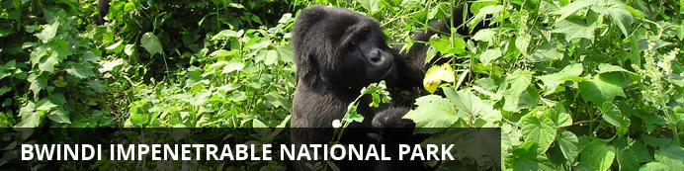

Uganda - Mountain Gorillas Safari
Bwindi Impeneterable Forest
3 Days / 2 Nights
2 Persons

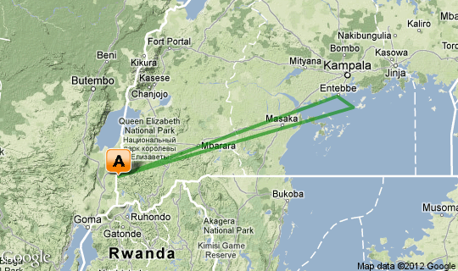

Click here to view your Virtual Itinerary

Overview
Gorilla trekking safari Bwindi Impenetrable Forest, Uganda to experiences the mountain Gorillas at Gorilla Forest Camp followed by the Ngamba Island Chimp Sanctuary
Destination | Accommodation | Nights | Basis | Room Type
Bwindi Impeneterable Forest | Sanctuary Gorilla Forest Camp | 2 | FI

Key
B&B: Bed and breakfast
D, B&B: Dinner, bed and breakfast
FB: Dinner, bed, breakfast and lunch
FB+: Dinner, bed, breakfast, lunch and activities daily
FI: Fully inclusive

Day 1: Bwindi Impenetrable National Park

Bwindi Impenetrable National Park
The Bwindi Impenetrable Forest is where you have the best chance of spotting a mountain gorilla family going about their business. Once you have your permit you are led across the rugged terrain and though the awe inspiring jungle to where the gorillas were seen yesterday and then you track them down. Aside from the amazing gorilla interactions there are numerous forest walks and 346 species of birds to track down, many of which are amazingly coloured.

Day Description
•You are met on arrival at Entebbe Airport , Uganda by the dmAFRICA representative who will assist you with the departure for the private charter flight to Bwindi (1 hour and 15 minutes).
•You are met at the airstrip and transferred to the Gorilla Forest Camp.
•On arrival, enjoy a late lunch and then hike to the waterfalls or take a village walk.
•Bwindi Impenetrable Forest impresses with a truly theatrical landscape - this is a region of volcanoes, jagged valleys, waterfalls, lakes and dramatic mountain ranges. And it is here, on a flat ridge high in the forest, that The Gorilla Forest Camp is tucked away. It's hard to fathom that such luxury and sophistication could be available in an area as remote as this, and we did face enormous logistical obstacles - but it was worth the wait.
•The Gorilla Forest Camp is the ideal base for a gorilla tracking adventure in Bwindi. Guests can dine under the stars and relax by the roaring campfire. On cooler evenings, the central cottage provides a warm shelter. Located within the National Park, Sanctuary Gorilla Forest Camp offers guests an unrivalled location, including the best bird and wildlife viewing in the Bwindi area. In fact the Gorilla Forest Camp often receives regular visits from the gorillas themselves, up to 4-6 visits per month. For the lucky guests in camp at those times, they may have the chance for a gorilla encounter without even leaving The Gorilla Forest Camp!

Overnight: Sanctuary Gorilla Forest Camp View iBrochure
Gorilla Forest Camp is a permanent luxury tented camp nestled in the mist-swathed rain forests of a mountainside in the heart of Bwindi Impenetrable National Park. The exclusive location – the sole property within the park’s boundaries - afford Gorilla Forest Camp the status of being the ideal base for gorilla tracking, primate viewing and birding excursions in the park.
Gorilla Forest Camp has been designed to blend seamlessly into this most atmospheric of environments, carefully-appointed towards the misty valleys and looming, forest-clad mountains that protect this fragile Eco-system. Accommodation is in 8 double tents, raised on wooden platforms, each with en suite facilities and hot and cold running water, WC, basin and unusually – a bathtub looking out onto the forest. Each tent has a spacious wooden veranda where guests can relax, enjoy a private meal and absorb the exotic mystery of the surrounding rain forest that provided the inspiration for the animation of Disney’s The Jungle Book.
The Gorilla Forest Camp offers a bar and dining cottage overlooking the rain forest, as well as a raised natural platform for open air dining. At night, a traditional African campfire is lit from where a lecture might be given by a visiting primatologist, the gorilla briefings are undertaken or guests simply admire the myriad brilliance of Bwindi’s crystal clear mountain sky
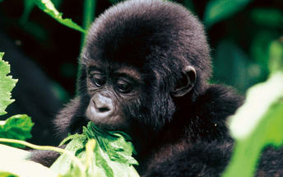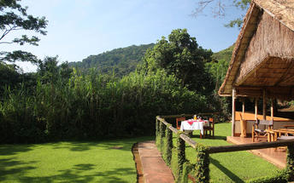

Activities

Included
Bed, All Meals, Most Drinks(local), Fees, Activities
Drinks (Local Brands)

Day 2: Bwindi Impenetrable National Park

Day Description
•Gorilla tracking this morning. Early start to the day with a briefing at 07h00 and then transferred to the starting point. From there it can take you up to several hours until you meet the gorillas.
•You spend 1 hour with these amazing creatures and will have time to take lots of photos while the gorilla family is resting, sleeping, eating or playing. No further activities for the day. (Gorilla permit costs are included).

Activities
Gorilla tracking - PLEASE NOTE THAT GORILLA PERMIT AVAILABILITY CANNOT BE GUARANTEED UNTIL WE RECEIVE PAYMENT OF US$500 PER PERMIT IN UGANDA TO SECURE PERMITS

Included
Bed, All Meals, Most Drinks(local), Fees, Activities
Drinks (Local Brands)

Recommended
Bwindi National Park
Gorilla Trekking

Day 3: Bwindi Impenetrable National Park

Day Description
•After breakfast and check out, transfer to Kayonza airstrip in time for the one hour private charter flight back to Entebbe departing at 09.00.
•You are met on arrival by the dmAFRICA representative and transferred to the jetty on the shores of Lake Victoria for a private speedboat to visit the Ngamba Island Chimp Sanctuary.
•Return to Entebbe late afternoon and transfer to the airport for your international flight.

Activities
Chimp Sanctuary

PRICE ON APPLICATION

INCLUSIONS
- Accommodation is for 2 nights on a full board basis including all meals, selected drinks and scheduled daily activities.
- All road and air transfers as indicated and with private vehicles and speedboat.
- Private charter flight Entebbe Kajjansi to Bwindi Kayonza and return.
- Services of an English speaking driver guide.
- Park fees.
- All activities described in the itinerary, unless specified as extras.
- Mineral water, tea and coffee in the vehicle.
- Medical Evacuation to a hospital in Nairobi.

EXCLUSIONS
- International Air Fares, entry visa fees, domestic and international departure tax
- All expenses of a personal nature
Tips and gratuities to your driver/guide hotel/camp staff etc.
PLEASE NOTE THAT GORILLA PERMIT AVAILABILITY CANNOT BE GUARANTEED UNTIL WE RECEIVE A DEPOSIT OF US$500 PER PERMIT IN UGANDA AND ACTUALLY PAY FOR THE PERMITS
IN CASE OF A CANCELLATION IN UGANDA, PERMIT PRICE IS REFUNDABLE AS FOLLOWS:
95 DAYS AND ABOVE 25% CANCELLATION FEE
50-94 DAYS 50% CANCELLATION FEE
14-49 DAYS 75% CANCELLATION FEE
0-13 DAYS 100% CANCELLATION FEE

Transport

Flight Information
Date | Flight | Departure Airport | Time | Arrival Airport
Day 1 |  | Entebbe International Airport [EBB] |  | Sanctuary Gorilla Forest Camp
Day 3 |  | Sanctuary Gorilla Forest Camp |  | Ngamba Island
Day 3 |  | Ngamba Island |  | Entebbe International Airport [EBB]

PRIVATE CHARTER AIRCRAFT WEIGHT AND TIME RESTRICTIONS

MAXIMUM PASSENGERS ALLOWED ABOARD FLIGHT: 2 PAX
AIRCRAFT USED: C-172
TOTAL WEIGHT LIMIT (CLIENTS AND LUGGAGE) KG: 80
TOTAL WEIGHT LIMIT (CLIENTS AND LUGGAGE) LBS: 396

PLEASE NOTE THE FOLLOWING:
AIRCRAFT PAYLOAD ROUGHLY ALLOWS EACH PAX 12 KG OF LUGGAGE, BUT THE OVERRIDING LIMIT IS THE TOTAL AIRCRAFT PAYLOAD
PLEASE NOTE IT IS THE BOOKING AGENT'S RESPOSIBILITY TO CHECK CLIENT WEIGHTS AND ENSURE THAT THE RIGHT AIRCRAFT IS REQUESTED AT THE TIME OF BOOKING
PLEASE NOTE PRICE QUOTED BY US IS BASED ON CLIENT NUMBERS. IF, BASED ON CLIENT WEIGHTS, IT IS DETERMINED THAT A LARGER AIRCRAFT IS REQUIRED, THE QUOTED PRICE WILL GO UP ACCORDINGLY
PLEASE NOTE ALL FLIGHTS TAKING OFF FROM ENTEBBE AFTER 1400 HOURS MUST BE DONE USING CESSNA 210 AIRCRAFT. OUR ORIGINAL QUOTE MAY INCREASE TO CATER FOR THIS ONCE WE RECEIVE FINAL INTERNATIONAL ARRIVAL TIMES

